

**PostgreSQL + Info-Gathering:**

**CMF - Azure PostgreSQL** **Single Server Info-Gathering Automation User Guide**

**For Script:**

**CMF-PostgreSQL-CLI.ps1**

**CMF-PostgreSQL-CLI-Linux.ps1**

**Document Summary**

|  |  |
| --- | --- |
| **Document Item** | **Current Value** |
| Document Title | CMF - Azure PostgreSQL Single Server Info-Gathering Automation User Guide |
| Program | CSU Migration Factory |
| Date Last Modified | 15-Dec-2023 |
| Date Last Reviewed | 18-Dec-2023 |
| Current Document Known Issue | N/A |
| Status | Initial |
| Document Description | This document provides the procedure/steps to execute the Automation script which gathers the Azure PostgreSQL Single Server details. |

**Revision History**

This section represents the change history of the document. Revisions of the document must be tracked by identifying a new version number, the date it was modified, the person making the change, and the reason for the change.

|  |  |  |  |  |
| --- | --- | --- | --- | --- |
| Date | Version | Change Description | Author | Reviewer |
| 15-Dec-2023 | 1.0 | Initial Version | Lekshmy, Arun, Mukesh, Chethan | Rackimuthu Kandaswamy |
| 18-Dec-2023 | 1.1 | Added SSL Mode | Lekshmy, Arun, Mukesh, Chethan | Sharad Khadtare,  Rackimuthu Kandaswamy |

Table of Contents

1. Executive Summary 4

1.1 Objective 4

1.2 Recommendations 5

2 Prerequisites for PostgreSQL Azure Single Server Info gathering - Execution 5

2.1 Non-Mission-Critical system 5

2.2 Operating System Requirements 5

2.3 Input Excel File 5

2.4 Windows User credentials 6

2.5 Storage Space & Folder read write permission 6

2.6 Internet access 6

2.7 Internet access to the URLs below: 7

2.8 Without Internet access to the URLs 7

2.8.1 Installing Azure CLI 7

2.9 PowerShell Version & Execution policy 10

2.10 Connectivity 11

3 Copying Script 11

3.1 Folder Name 11

3.2 Script and Input file 12

4 Preparing the INPUT CSV File 12

5 Executing the Script 13

5.1 Azure PostgreSQL Info Gathering execution 13

5.1.1 Create support folders (Logs, Output, Downloads etc) 14

5.1.2 Validate Azure CLI 15

5.1.3 Azure Portal authentication 16

5.1.4 Export Info-Gathering details and generating JSON files 16

5.2 Server_List Input File 17

5.2.1 Azure PostgreSQL Single Server JSON output 17

5.3 Azure PostgreSQL Single Server Output excel file 18

5.4 Automation Script Transcript Log 19

# Executive Summary

## Objective

This document provides the procedure/steps to execute the Automation script (CMF-PostgreSQL-CLI.ps1) which gathers the Azure PostgreSQL Single Server details.

The following PostgreSQL information is gathered from the given Azure Subscription:

* Host_Name
* Resource_Group
* Port
* VCore
* Auth_Type
* User_ID
* DB_Name
* Tenant
* Subscription_ID

## Recommendations

Key recommendations are as follows:

1. Run the script on Non-Mission-Critical systems ONLY (i.e.**NOT** on any production server)
2. Windows 10, Windows Server 2012, Windows Server 2012 R2 and above
3. Connectivity must exist between the SYSTEM which runs the CMF_PostgreSQL_Azure_Info_gathering Automation script and Azure Cloud
4. Powershell 5.1 version

# Prerequisites for PostgreSQL Azure Single Server Info gathering - Execution

## Non-Mission-Critical system

* **Don't install and run the Automation scripts on any mission-critical production server**

## Operating System Requirements

* Supported Operating System

Windows 10, Windows Server 2012, Windows Server 2012 R2 and above

## Input Excel File

**Important Notes:**

* This script is based on the csv file named ‘Azure_Subscription’ and the following columns in the Input csv file
* INPUT CSV FILE name must be **Azure_Subscription**
* **Column Name must be kept as shown below, change in names will result in errors**
* **Values in the column must be correct, incorrect values will also result in errors**

|  |  |
| --- | --- |
| **Column Name** | **Note** |
| **Tenant** | **Azure Subscription Tenant ID** |
| **Subscription_ID** | **Azure Subscription ID** |

|  |  |  |
| --- | --- | --- |
| **Seq.No** | **File** | **Note** |
| 1 |  | Sample: **Azure_Subscription.csv (Input File)** |
| 2 |  | Sample: **Server_List.csv (Output File)** |

## Windows User credentials

Windows users must have privileges to install the following software

* Azure CLI

## Storage Space & Folder read write permission

* Windows users must have the privilege to create folders and write the assessment results to that folder
* Minimum disk free space required is 1GB

## Internet access

* Connectivity must exist between the SYSTEM which runs the CMF-PostgreSQL-CLI.ps1 / CMF-PostgreSQL-CLI-Linux.ps1 Automation script and Azure Cloud.

## Internet access to the URLs below:

|  |  |
| --- | --- |
| **URL** | **Note** |
| https://aka.ms/installazurecliwindows | Azure CLI (Windows) |
| https://learn.microsoft.com/en-us/cli/azure/install-azure-cli-linux?pivots=dnf | Azure CLI (Linux) |
| <https://aka.ms/PSWindows> | Powershell ( Windows ) |

## Without Internet access to the URLs

**Note:** Follow the instructions below to download all the software manually to a server where internet connectivity is enabled. Once all the software is downloaded, move all of it to the server where CMF_PostgreSQL_Azure_Info_gathering automation script will be executed and install all of them one by one.

### Installing Azure CLI

1. Paste the download link in web - <https://aka.ms/installazurecliwindows> or https://learn.microsoft.com/en-us/cli/azure/install-azure-cli-linux?pivots=dnf



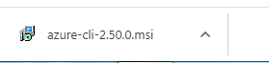

1. Launch the downloaded offline installer **azure-cli-2.50.0.msi** orlatest version at the time of download**.**

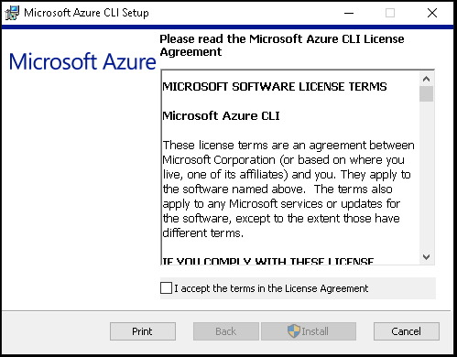

1. Read and accept the license terms.
2. Click on Install.

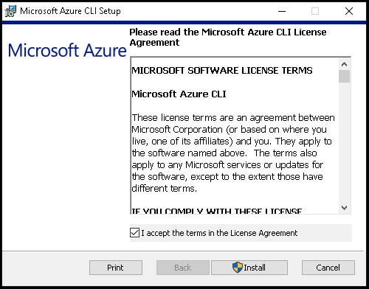

1. Azure CLI Installation is in progress

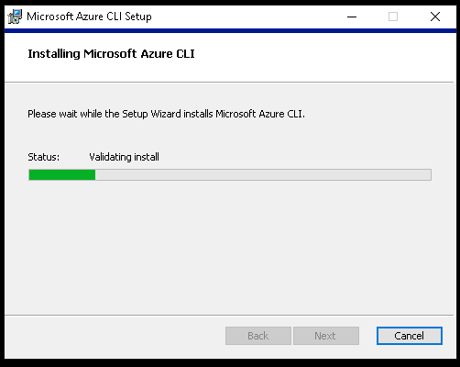

6. Once the installation is complete, click on Finish

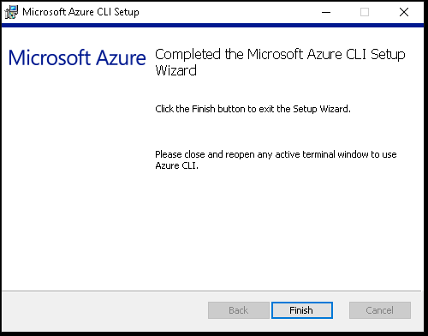

## PowerShell Version & Execution policy

Execute the below commands from windows PowerShell as Administrator.

1. To find the PowerShell Version

* Get-Host

1. Set the PowerShell execution policy

* **Set-ExecutionPolicy Unrestricted -Scope CurrentUser**



## Connectivity

* Connectivity must exist between the SYSTEM which runs the Azure PostgreSQL Single Server Info Gathering Automation script and Azure Cloud.

# Copying Script

## Folder Name info-gather ( unzip into folder files received )

* Login into a Non-Mission-Critical system (i.e.**NOT**on any production server) from where the PostgreSQL Automation script is to be run
* Create a folder C:\Info-Gather (you may choose any available drive)

## Script and Input file

* Rename rename.txt rename.bat and run in info-gather folder

# Preparing the INPUT CSV File

In Order to support the Info Gathering process, INPUT CSV FILE has been provided with Azure Subscription data.

**Each column will represent an Azure Subscription detail for PostgreSQL** **Azure Single Server Info Gathering**

* Once the input file is prepared Copy the file (**Azure_Subscription.csv**) under the folder created in the previous step (C:\PostgreSQL_Azure)

# Executing the Script

## Azure PostgreSQL Info Gathering execution

* Open windows Command prompt as **Administrator**

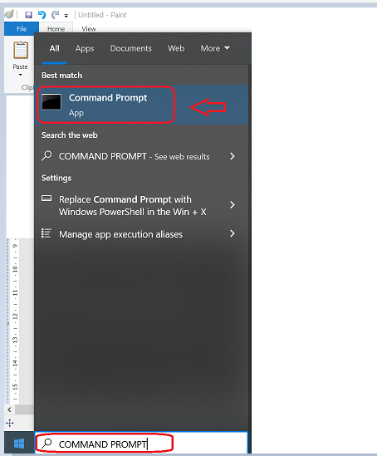

Change the working directory/folder to the folder where you created/copied the script (CMF-PostgreSQL-CLI.ps1 and CMF-PostgreSQL-CLI-Linux.ps1) in the previous step

**Note:** The file size may change based on the current policies and bug fixes

* Enter the following command at the windows command prompt to trigger the CMF-PostgreSQL-CLI.ps1 script.

**Powershell.exe -ExecutionPolicy RemoteSigned -File .\CMF-PostgreSQL-CLI.ps1**



### Create support folders (Logs, Output, Downloads etc)

After triggering the automation all the support folders (Logs, Output, Downloads etc. ) will be created automatically by the automation script in the C:\PostgreSQL_Azure folder

### Validate Azure CLI

* Automation script validates the Azure CLI. If not found, automation will initiate installation

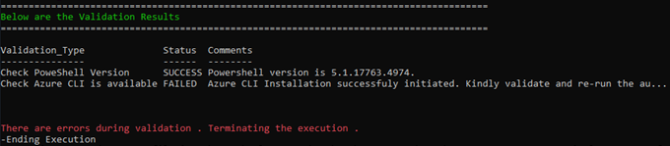

* Once Azure CLI Installation completes successfully and if you encounter above error message kindly close the Command Prompt and validate Azure CLI by re-running the automation script again.

* PowerShell version and Azure CLI are validated successfully.

### Azure Portal authentication

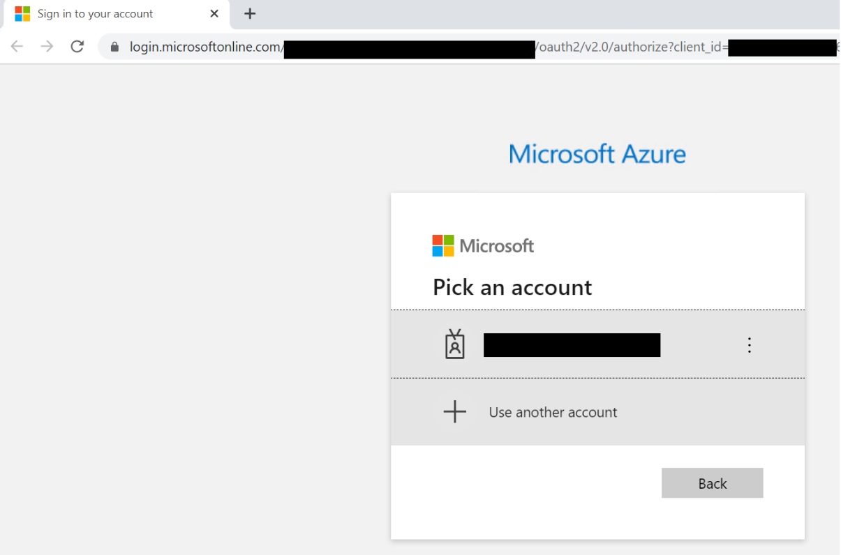

* **Automation requires the Azure portal authentication**

### Export Info-Gathering details and generating JSON files

* Once Azure portal authentication is successful, Automation gathers Azure PostgreSQL Single Server details to update them in spread sheet. Also, Azure CLI’s PostgreSQL commands output will be exported to JSON files.
* The JSON files can be found in the Folder Output 🡪 Single

## Server_List CSV File

**Note:**

* Initially except the headers, the “Server_List” rows will be empty
* “**Server_List**” csv file will be automatically populated with the details of the PostgreSQL Single server/instance i.e. Host_Name, Resource_Group, VCore, Auth_Type, User_ID, Tenant, Subscription_ID , SSL_Mode **once the Script execution is complete**
* You can use these server details and copy it to the CMF-PostgreSQL_Server_Input_file.csv for Windows/Linux PostgreSQL Server Info-gathering

### Azure PostgreSQL Single Server JSON output

The Following JSON output files will be generated for each Azure PostgreSQL Single Server from the given Azure subscription.

## Azure PostgreSQL Single Server Output excel file

Output.xlsx file will be generated for all the PostgreSQL Single Server/Instance(s) from the given Azure subscription. Azure CLI’s output are as follow.

* Server List
* DB_Details
* Configuration_Data
* AD_Admin
* FW_List (Firewall Rules)
* Replica_List

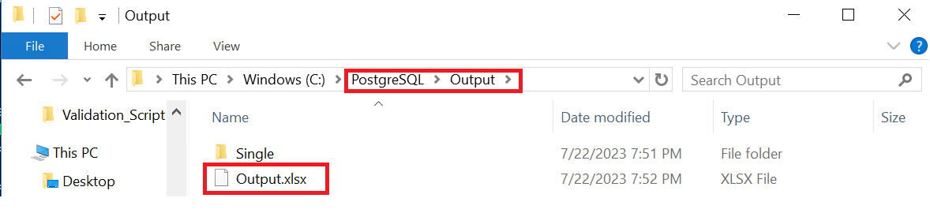

**Note:** output file will be generated in excel format as above (.\Output\Output.xlsx)

**Note**: work sheets will be created with details in output.xlsx file as above.

**Note: Please Share Compressed Output Folder and to CMF Team.**

## Automation Script Transcript Log

**Note:** For the Automation, transcript will be generated in text format as above

(.\Logs\ CMF_PostgreSQL_Azure_Info_gathering_*.txt)